**Strategy to enter the market**

**(Intention: To have more customer, retain customer, to make more sell, finding method so that customer will prefer us more.)**

**Overall Features of our potential customer**

1. Age above 50
2. Having diabetes
3. Having other lifestyle diseases like polyuria, polyphagia, polydipsia, and hypertension.
4. No diabetes but kind of diseases.
5. Having heart diseases
6. High cholesterol values
7. Heart rate is above 140 mostly
8. Belonging to Middle class
9. Having internet connection
10. Having blood pressure issues.
11. Belonging to states Tamil Nadu, Kerala, Maharashtra,( diabetes , full body checkup)
12. District wise – Chennai, Madurai, Coimbatore, Pathanamthitta**,** Trivandrum (diabetes , full body checkup)

The process of determining product-market fit. Product-market fit means that a company’s product or service solves a problem for the customer and the customer finds this solution valuable enough to pay for it.

**Strategy points** –

Psychograph of region, values, lifestyle

Age group above 50

Brand awareness

Pricing

Competitors crack.

Marketing mix 4p

---------------------------------------------------------------------------------------------------------------------

**What our customers want & need**:

Consumer needs and wants are not necessarily same. Need is to do lab test for diseases facing for nominal cost. Want is based on values the consumer is holding. It can be cleanliness, Behavior, Communication etc. Also already 10 competitors are in market who are fulfilling needs and wants. We need to not just fulfill need in affordable rates for middle class consumer but also fulfill their want e.g. – values, emotions of Indian people. Detailed given below.

**There are 4 kinds of buyers**:

1. Quality buyers – best w/o regard to cost
2. Service buyers – personal caring and service
3. Value buyers – best value for money. Quality should match price
4. Economy buyers – cheapest alternative which minimize cost

Our target consumer belongs to Service & value buyers. As along with patient other family members are also involved in taking decisions about this case.

**South Indian people lifestyle and values**:

They place a premium on hospitality and avoiding conflict. They offer food or snack every time guest or some person who come home. In general, people from southern India have a reputation of being friendlier and more excitable than Indians from the north. They tend to put their faith in science rather than idealism and greatly value humility. As per any Indian they have relational values and emotions. They emphasize on neat work and very intellectual as south Indian people are famous for neat work and their intellect. Here Emotions, human values, culture pride is seen. Most people are from middle class and lives in family or more than 3 members. It is not unusual for elderly people or couples to live alone. In metros like Chennai scenario can be different as more students and bachelors live and it’s a metro city.

**Method to approach the customers (deal with them)**:

This is a B2C market and your business model needs to be made considering factors of direct consumer sales. As the target segment is above age 50 and Indian also belonging to core Indian regions one factor is our connection with them must have some emotion linked in it. Our service must represent in their values, emotions. E.g. - how Shadi.com and amazon.in is doing with their ads, and representation. Both encourages the link between tradition and modern lifestyle. They emphasizes on traditional values the relations etc.

Similarly in this biotech startup – the relation between children and parent or grand parents can be shown or themed. As many Indians expects their children will take care of them in their old age also some old couples are alone, here we will serve and help. We must build relation in a way the trust is built for us and the own-ness (Apanepn Ki feeling) feeling is developed. The doctor is considered as god. And relation are as uncle aunt, etc. with unknown people whom you see or meet often. Thereby if we considered these values, emotions then we can connect with customer largely. According to this our advertisement must be themed. Here if these things are carried out well then customer himself starts recommending other about our product or service (also known as organic marketing). Take the feedbacks and analyze them so that you can improve your service. From feedbacks we can know where we fail and points for which customers prefer other brands or company. Also what other companies are lagging or what the customers’ pain, excitement, and interests are must be known and this can be figured out from feedbacks in great manner as that will direct information from customer. With trust and quality service customers will retain and one thing to consider in our case customer who are taking home checkup service will retain more but those who buy device directly won’t retain much as device life must be more than at least 3-4 years.

**Branding of product and reaching method**:

It’s a startup and brand building is next level thing, but awareness must be made in society about us. This branding is based on the nature of costumer. Targeted group is from middle class and to reach out to them hence following methods are useful – Medical shop branding, Bus advertising, Cab advertising. YouTube and TV ads. The ad on the medical shops encouraged the people who are actively seeking to buy their prescriptions get to about us and our advantages. Chennai people largely travel by bus. Buses are one of the major transport media in region for middle class. Placing ads on buses can help in reaching out to the mass audience similarly for Cab branding too. Even the UI or for example how your app is seen on play store. Those visuals also determines if a person after looking first image will continue to see further features displayed on play store or will go back and see other apps. Once you know the costumer behavior or general mindset you can decide content for branding. The biggest challenge for B2C marketers is reaching and engaging their customers in the digital age. Consumers are looking for content, entertainment, and connections. We also need to be careful that ADs don’t turn interruption. Social media marketing helps too. Though less percentage of actual targeted patient i.e. above age 50, 60 are sing social media, still other family members are exposed to social media and they are also needed to be convinced with our product. If the startup has website then it contributes very much in marketing. Almost immediately after showing what business you’re in, it’s time to start building credibility. Ratings, reviews, best sellers, top-rated products, testimonials, certifications, awards, press mentions, endorsements, and logos of companies all help add social proof. This will happen gradually as we are in early market scenario. This builds strong trust in people who are not yet your customer. And those who are already customer, trust is built with your approach to them your service and the points given in “Method to approach the customers (deal with them)” above.

**Portraying product and service**:

Similar products and services are available in market who have done customer acquisition already. Hence we must present our product and service in way it showcases its essence, its need and value (importance). We must show the advantage of our biotech device, its accuracy, etc. promises that we make. Home going service can be portrayed as “As many patient cannot go out because of physical ailments, sometimes there is no one to take to pathology, With our team coming home it gives patient the ease of checkup at his/her own place.” Etc. Along with this pricing is affordable for middle class group. These things contribute in developing positive mindset in patients or their relatives (customers) about company.

**Cracking the competition:**

Company can position their products and services according to four variables: Product quality, service quality, and price and fulfilment time. Reviewing your internal strengths and comparing them to those of your competitors, a differentiation strategy that positions your offering above those of your competitors can be achieved giving you a competitive advantage. A value proposition gives benefits of the products and services to reinforce the core proposition to differentiate it from the competitors. It also helps in communicating messages that will strategically fit with its indented customers, providing a direction for all marketing messages.

Figure out which issues or pains of customers are still remaining aside by existing solutions and products.

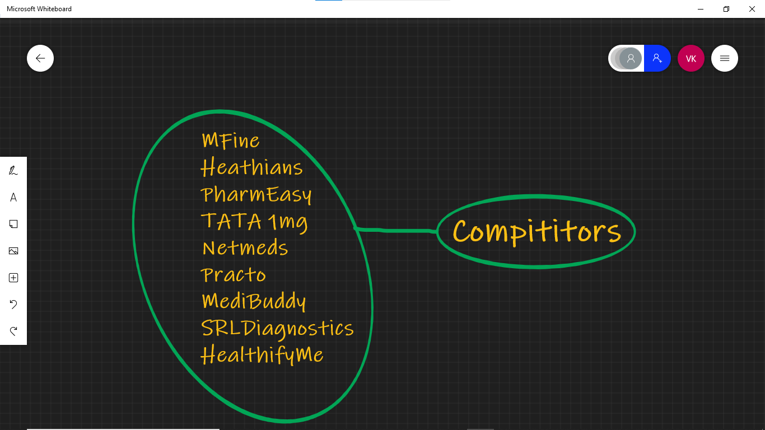

Fig – Existing competitors

One Thing about competitors is that their main focus is on online consultation or they are known for online consultation and medicine e-commerce. Mfine, Pharmaeasy, TATA 1mg is mostly known for delivery of medicines. Practo is known for online consultation. They started with online consultation and now they entered into various services of delivering medicines, selling health products and lab test at home.

1. Vitamin Profile. ₹ 1285 ₹ 899 onwards.
2. Thyroid Profile. ₹ 357 ₹ 299 onwards.
3. Diabetes Screening. ₹ 713 ₹ 499 onwards.
4. PCOD Test. ₹ 1856 ₹ 1299 onwards.
5. Liver Function Test. ₹ 470 ₹ 329 onwards.
6. Kidney Function Test. ₹ 499 ₹ 349 onwards.
7. Advanced Thyroid Care. ₹ 999 ₹ 699 onwards.

These are pricing of Mfine lab tests.

For pharma essay pricing range is around 800 which is a discounted price.

They have acquired the potential market but pricing is on average about Rs.800. Hence to crack the competition our service our product first be the outperforming and pricing must be affordable for the middle class.

**Pricing:**

Pricing can range between Rs.400 to Rs.800 to be affordable for patients. As we saw in earlier points. In Chennai as a metro city, pricing can be increased compared to Madurai and Trivandrum.

Also the device can vary between Rs.1500 to Rs. 2500. It will be affordable as it will serve patients for at least 5 years. These are starting pricing ranges as it’s an early market scenario.

Potential customer base in the early market is 100k round off values of all services included for target customers.

Potential Customer Base * Your Target Price Range = Potential Profit

Hence, **100k * Rs. 800 = Rs. 8,00,00,000.**

So Potential profit is Rs. 8 crores. If we need to work out and crack competition as given above and build strong trust and relation with customers as given above. Then this can be successful in the early market and will hustle in coming years.

**Marketing mix 4p:**

1. Product (or Service) - It facilitates patients with full body checkup and also lab tests for Diabetes, Blood pressure and detects vitamins deficiency. Patients can book home lab tests or buy the bio-tech device by themselves from the company's online platform.

How is it different from products by your competitors?

This Biotech device is more easy to use that patients can use directly by buying on online platform

1. Place - The target market is Tamil nadu, Kerala for diabetes and full body checkup. See above points
2. Price - Pricing can range between Rs.400 to Rs.800 to be affordable for patients. As we saw in earlier points. In Chennai as a metro city, pricing can be increased compared to Madurai and Trivandrum. Also the device can vary between Rs.1500 to Rs. 2500. It will be affordable as it will serve patients for at least 5 years. These are starting pricing ranges as it’s an early market scenario.
3. Promotion - Medical shop branding, Bus advertising, Cab advertising. YouTube and TV ads. The ad on the medical shops encouraged the people who are actively seeking to buy their prescriptions to get to know us and our advantages. Chennai people largely travel by bus. Buses are one of the major transport mediums in the region for the middle class. Placing ads on buses can help in reaching out to the mass audience similarly for Cab branding too.  Social media marketing helps too. Though less percentage of actual targeted patients i.e. above age 50, 60 are using social media, still other family members are exposed to social media and they are also needed to be convinced with our product. If the startup has a website then it contributes very much in marketing. Almost immediately after showing what business you’re in, it’s time to start building credibility. Ratings, reviews, best sellers, top-rated products, testimonials, certifications, awards, press mentions, endorsements, and logos of companies all help add social proof.  This will happen gradually as we are in an early market scenario. This builds strong trust in people who are not yet your customer. And those who are already customers, trust is built with your approach to them, your service and the points given in “Method to approach the customers (deal with them)” above.

**What our costumers wants & needs**:

Consumer needs and wants are not necessarily same. Need is to do lab test for diseases facing for nominal cost. Want is based on values the consumer is holding. It can be cleanliness, Behavior, Communication etc. Also already 10 competitors are in market who are fulfilling needs and wants. We need to not just fulfill need in affordable rates for middle class consumer but also fulfill their want e.g. – values, emotions of Indian people. Detailed given below.

**Psychograph of region, values, lifestyle**:

As the target segment is above age 50 and Indian also belonging to core Indian regions one factor is our connection with them must have some emotion linked in it. Our service must represent in their values, emotions. E.g. - how Shadi.com and amazon.in is doing with their ads, and representation. Both encourages the link between tradition and modern lifestyle. They emphasizes on traditional values the relations etc.

Similarly in this biotech startup – the relation between children and parent or grand parents can be shown or themed. As many Indians expects their children will take care of them in their old age. The doctor is considered as god. And relation are as uncle aunt, etc. with unknown people whom you see or meet often. Thereby if we considered these values, emotions them we can connect with costumer largely.

(Branding) How you deal (reach to) with consumers, your ads, promotions, while giving service how to bond with them or set relation with consumer will determine various things. This strategy must set seeing psychograph and lifestyle aspects of that region.

As a new startup generally Adoption rate is low, but as targeted customer is from middle class who always seeks affordable and small pricing services, and also prefer the product based on the approaches as said above of emotions and values. Once we got connected with these people the brand awareness grow.

<https://factsanddetails.com/india/Minorities_Castes_and_Regions_in_India/sub7_4c/entry-4200.html>